The MacMillan surgery helping our patients to “Give a T.O.S.” about head and neck cancer.

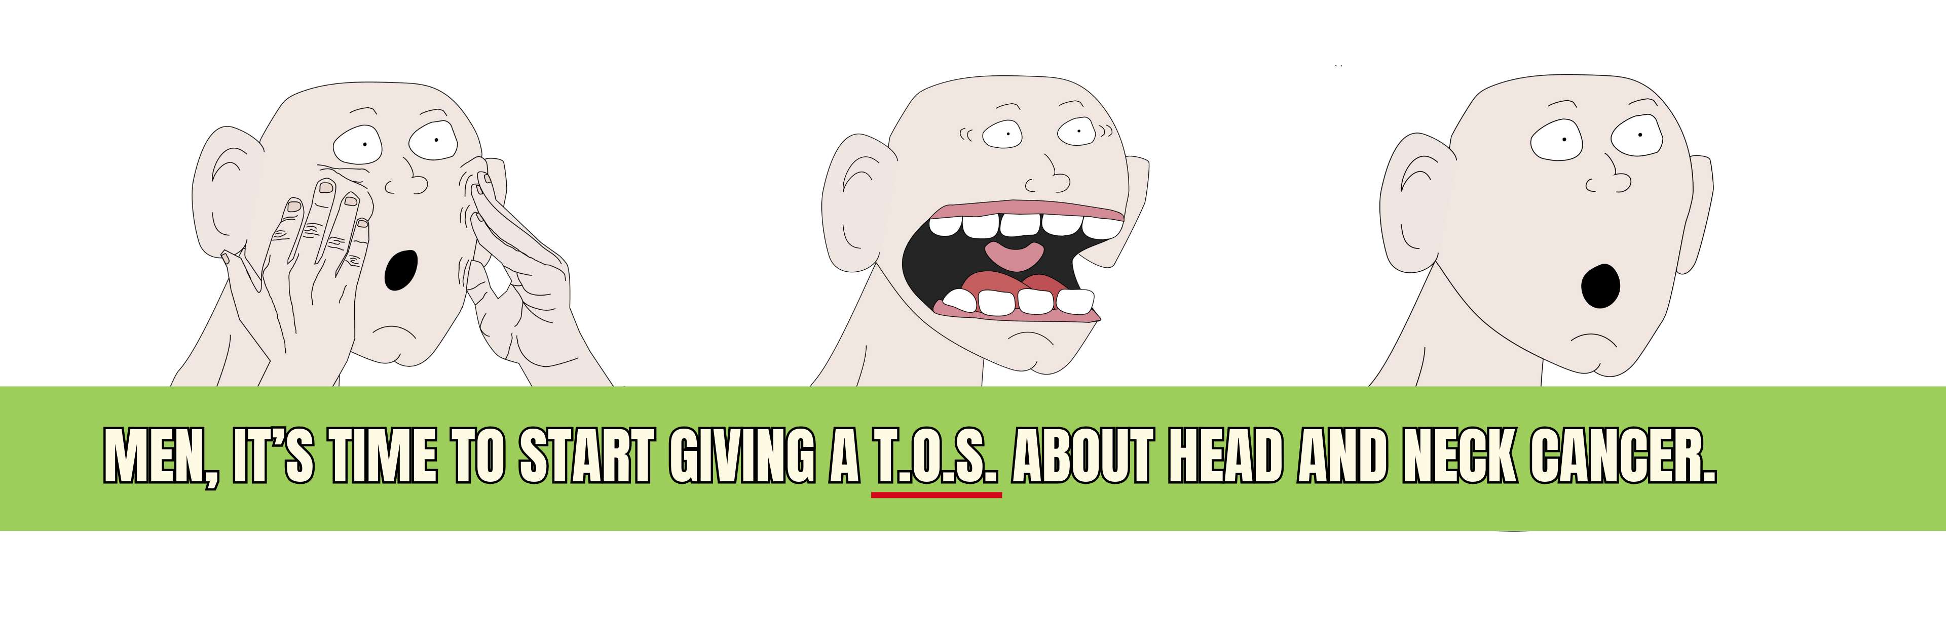
Head and neck cancer kills 4,000 people each year in the UK and more than 2 in 3 people who get these types of cancers are men.

Additionally, according to North West Cancer Research rates of head and neck cancers in Merseyside are 32% higher than the UK average.

This is why we are partnering with the Cheshire and Merseyside Cancer Alliance on a campaign to support more men in the local area to check themselves for signs and symptoms once a month.

This campaign encourages men over 40 to “Give a T.O.S.” about head and neck cancer by following three simple steps:

- Touch - Feel around for any lumps on your neck, lips, or in your mouth.

- Open Wide - Look in your mouth and on your tongue for any ulcers or red / red and white patches.

- Speak - Listen out for any hoarseness in your voice.

This check process can help our patients spot the signs and get checked out at our practice sooner, so we can tackle any possible cancer quicker.

As part of this campaign, we will be sending out an informational letter to a handful of our male patients followed by monthly reminder text messages. This service will run automatically for an initial 10-week period, starting on the week commencing 26th January 2026. It can be opted out of by anyone at any time.

During this period, you may also see some social media posts and materials out in the community to help remind you and your loved ones of how important this quick and simple monthly check is.

Regardless of your age, gender, or whether we have contacted you, if you have had any of the symptoms listed in the check for 3 weeks or more, please contact the practice now on <number>.

For more information, visit the Cancer Alliance webpage: https://cmcanceralliance.nhs.uk/public-information/give-a-TOS

